1. 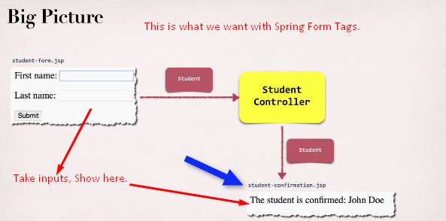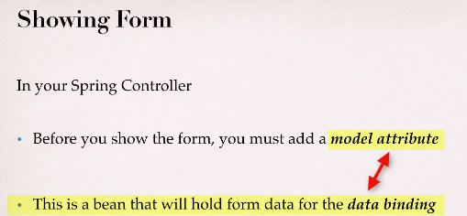
2. 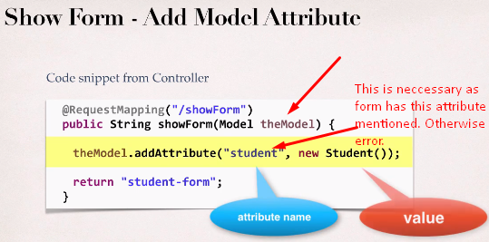  
   You would say that even though, the attribute “student” is empty we are not setting its data, then what is the need for this attribute.  
   Answer: As the form is used for new student and existing student too so we have used <form modelAttribute=”student” to show data of existing student, so it becomes necessary to add attribute student when showing form for new student too. See the following slide.
3. 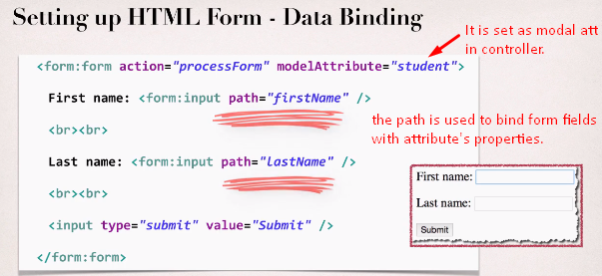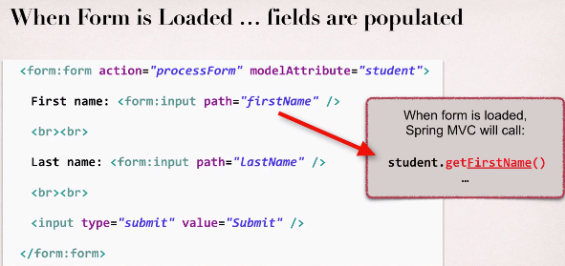  
   When form is shown, the getters methods of attribute object are called.
4. 